Git Assignment 1

Use GIT as local VCS Steps to follow:

1.Create a directory ‘project_dir’ & cd to ‘project_dir’

 

2.Initialize the git version database.



3.Create a new file index.html.



4.Check the git status. You should find index.html as an untracked file.

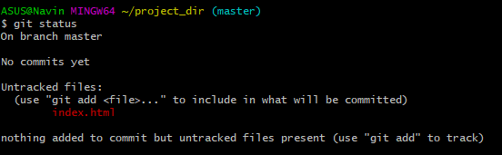

5. Stage the index.html file.



6. Commit index.html

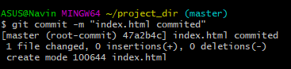

7. Make a few changes in index.html & create a new file info.txt file.



8.Check git status. You should find index.html & info.txt as untracked files.

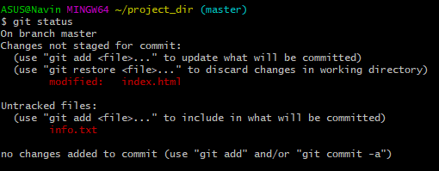

9. Configure GIT to ignore all txt files.



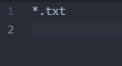

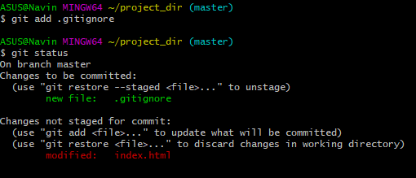

10. Again check the git status. You should find only index.html as an untracked file.



11.State & commit index.html  
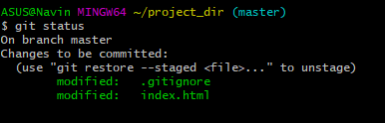

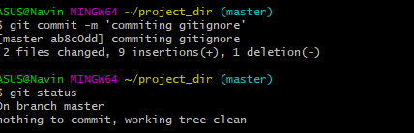

12. Log all your commits so far

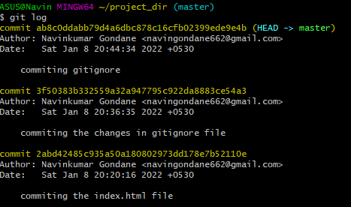

13. Make some changes in index.html

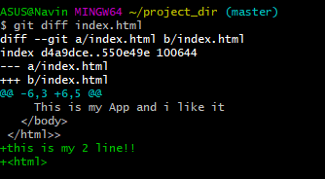

14. Revert the change made in the previous step using git command.



15. Again change index.html.

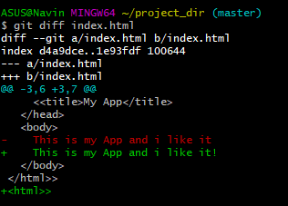

16. Stage index.html.

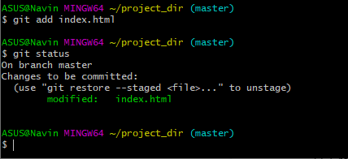

17.Revert back the last stage.

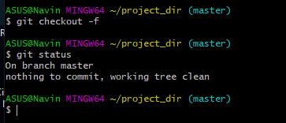

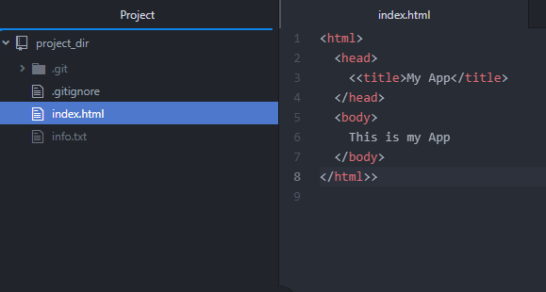

18.. Rename ‘add’ command to ‘my-add’.



19. Using my_add command Stage index.html again & commit the changes.

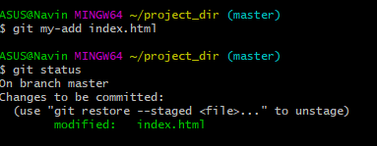

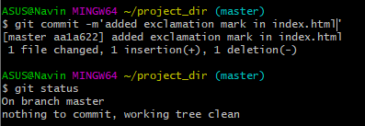

20. Revert the last commit.

